DBMS ASSESMENT:

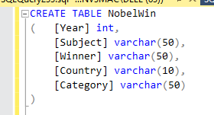

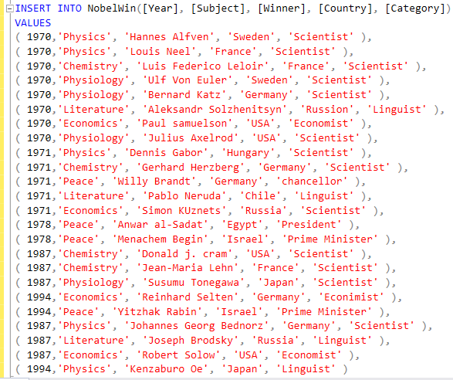

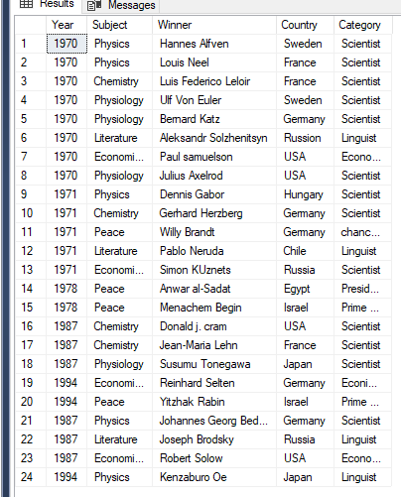

**Write sql query to find the nobel prize winners of the year 1970. Return year,subject and winner**



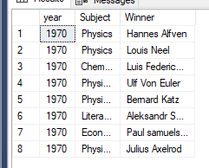

**Write sql query to find the nobel prize winners in chemistry between the years 1965**

**and 1975. Begin and end values are includedReturn year, subject, winner and**

**country**

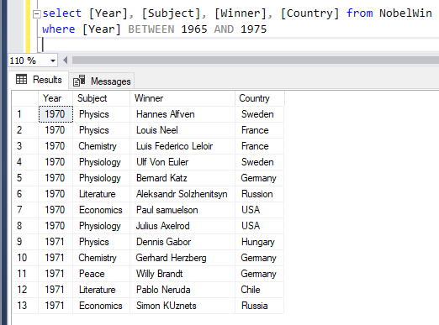

**Write sql query to retrieve the details of the winners whose first name matches with**

**the string ‘Louis’. Return year,subject,winner,country**

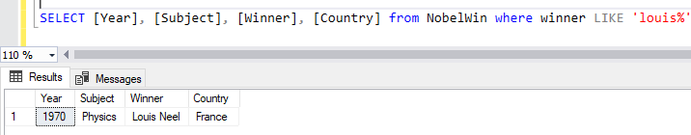

**● Write sql query to find Nobel prize winners for the subject that does not begin with the letter ‘P’. Order the result by year, descending and winner in ascending**

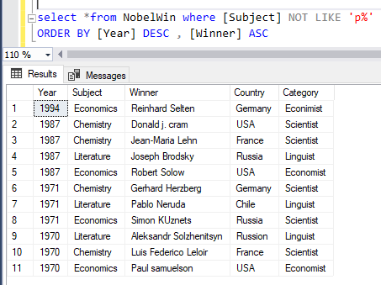

**Write sql query to find the details of 1970 Nobel prize winners. Order the result by**

**subject, ascending except for ‘Chemistry’ and ‘Economics’ which will come at the**

**end of the result set. Return year, subject, winner , country and category**

